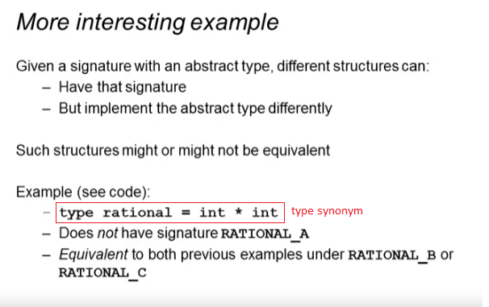

SIGNATURE A

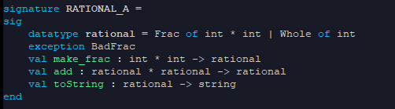

* Reject, rational is strict

SIGNATURE B

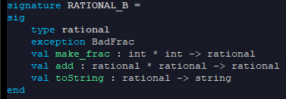

* Outside world will not know that rational must be int\*int

SIGNATURE C

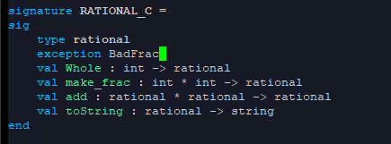

Rational 3 code, using SIGNATURE B

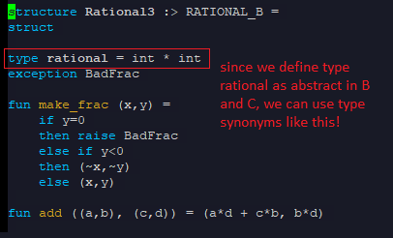

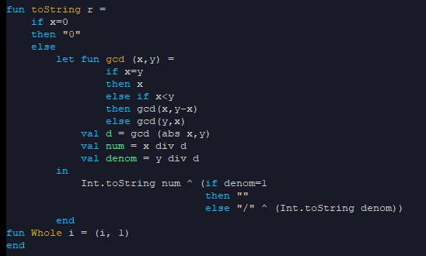



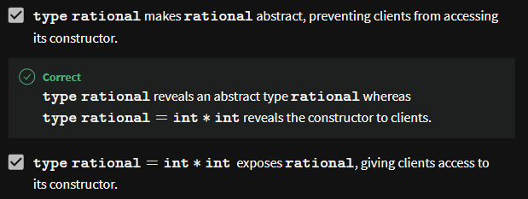

Rational 3 code, using SIGNATURE C

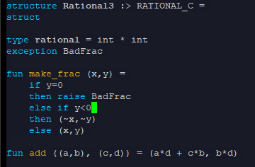

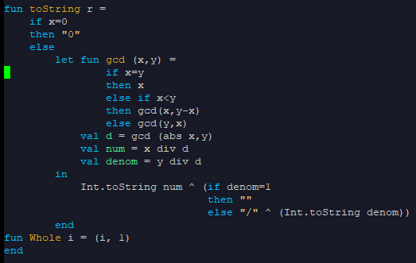

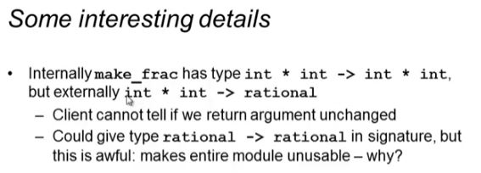

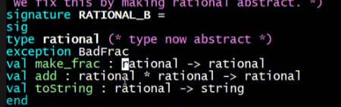

* The clients will not know where to get their first rational to be used in the functions

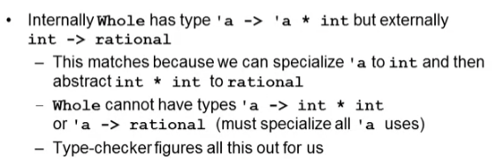

* Module:
  + 
  + Inside this we can call Whole with string
* Signature:
  + 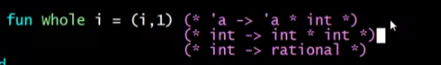
  + Correct! Because our module type is more general than the signature type of Whole
  + But clients can only call Whole with int because of the signature!
  + 